COL215 Hardware Assignment 1

~by Adithya Bijoy and Anish Banerjee

(2021CS10571 and 2021CS10134)

## Design Decisions and Lab Work

We began by making the seven-segment decoder, MUX and timing circuit in separate modules. Then we imported them as components in a file to combine them and make the final design.

In the lab, we programmed our device and tried some inputs. The snapshots of the outputs obtained have been attached below.

## Simulator for Decoder

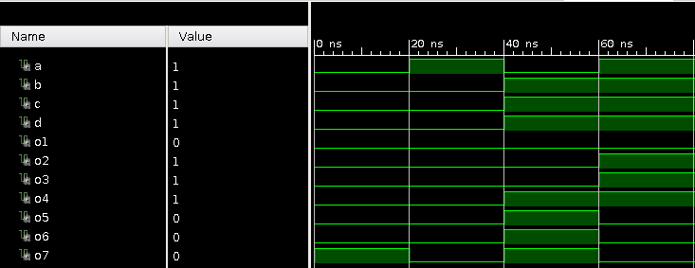

## Simulator for MUX

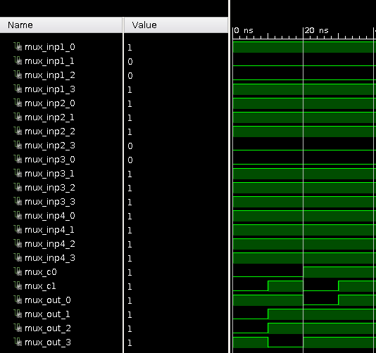

## Simulator for Timing Circuit

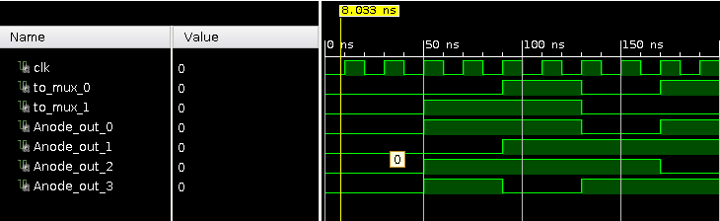

## Simulator for combine

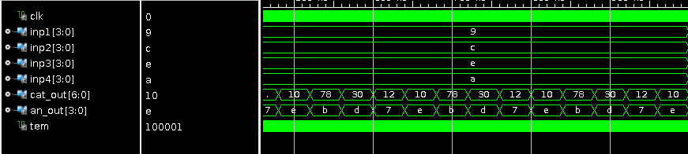

## Synthesis Report

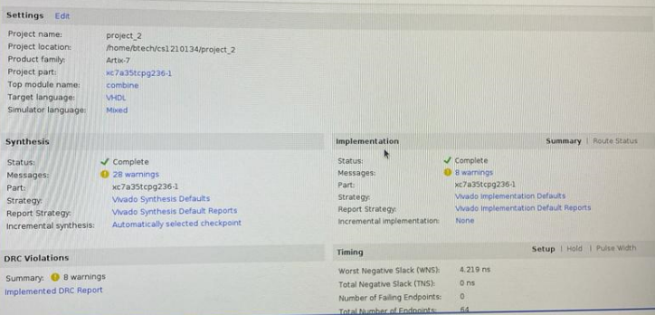

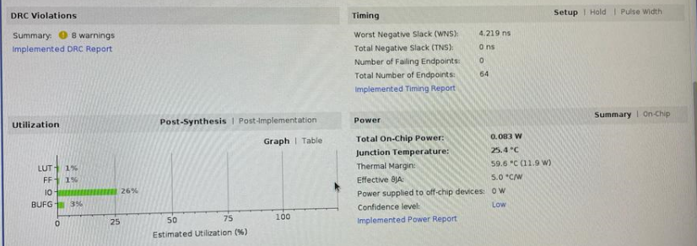

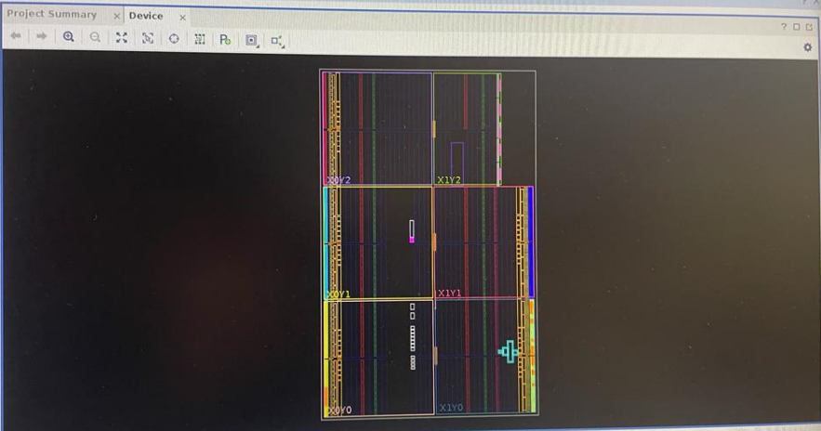

*Note: The Vivado Synthesis Report and Utilization Report have been added in the zip file as separate .txt files*

## Snapshots of Working of the Implementation

